DevSpeed Technologies Co., Ltd
A Report on Overview Of The Company

Prepared by: Sou Chanrojame
Orn Pheakdey
Then Sivthean
Long Neron
Le Sreyma

Group Members (Group 1)

Name | Role | Tasks
Sou Chanrojame | Leader | DHCP Server, VPN Server, FTP Server, DNS Server, Failover Cluster, Mail Server, Terminal Server, Fine-Tuning LLM
Orn Pheakdey | Member | File Server, Proxy Server
Then Sivthean | Member | Web Server, Container (Docker)
Long Neron | Member | Database Server, Domain Controller
Le Sreyma | Member | Backup Server, Load Balancing

TABLE OF CONTENTS

- Introduction
- Company Overview
- Infrastructure of Company
3.1 Departments
3.2 Diagram
- Conclusion

1.Introduction
DevSpeed Technologies Co., Ltd. is a forward-thinking software development company dedicated to delivering high-performance digital solutions with speed, precision, and innovation. We specialize in building modern web, mobile, and cloud applications that empower businesses to grow and adapt in a fast-changing digital world.
Our team of experienced developers, designers, and engineers focuses on quality-driven development, agile processes, and cutting-edge technologies to turn ideas into scalable products. Whether it's a custom enterprise system, API integration, or a complete digital platform, DevSpeed Technologies combines technical excellence with a deep understanding of our clients’ goals.
At DevSpeed Technologies, we believe that speed matters — but quality defines success.
2. Company overview
This company focuses on designing and implementing a complete enterprise server environment using Windows Server 2022 as the main operating system for all services.
The system is intended to support DevSpeed Technologies’ internal operations, software development workflows, and customer-facing services.
The company covers 15 major server roles and functions:
- File Server: Centralized storage and document sharing among teams.
- Proxy Server (Caching, Control Access): Enhances internet performance and filters web access.
- DNS Server: Provides name resolution for internal and external network connectivity.
- DHCP Server: Automatically assigns IP addresses to devices on the corporate network.
- VPN Server: Offers secure remote access for employees working from home or client sites.
- Terminal Server (Thin Clients): Enables remote desktop access for lightweight client machines.
- Web Server: Hosts DevSpeed’s websites, web apps, and client portals using IIS.
- Mail Server: Manages internal and external email communications.
- Database Server (SQL Server, MongoDB, PostgreSQL): Stores critical data, analytics, and application records.
- Backup Server: Provides regular backup and disaster recovery solutions.
- Load Balancing: Distributes workloads across multiple servers to ensure performance and reliability.
- Failover Cluster: Guarantees high availability by automatically switching services during hardware or software failures.
- FTP Server: Facilitates secure file sharing with clients and partners.
- Container (Docker): Hosts containerized applications and microservices for development and testing.
- Domain Controller: Manages user authentication, authorization, and security policies through Active Directory.
This integrates all these components into a unified Windows Server 2022 ecosystem, ensuring scalability, performance, and cybersecurity for DevSpeed Technologies’ growing digital operations.

3. Infrastructure of company
3.1 Departments

Department | Key Responsibilities
Software Development Department | Core of the company — responsible for backend, frontend, mobile, and cloud application development. Focuses on writing efficient, scalable, and maintainable code.
UI/UX Design Department | Designs user-friendly interfaces and ensures excellent user experience across all platforms (web and mobile).
Quality Assurance (QA) & Testing Department | Performs manual and automated testing to ensure software reliability, security, and performance before deployment.
Project Management Office (PMO) | Manages project timelines, client communications, and coordinates between technical and design teams using agile/scrum methodologies.
Research & Development (R&D) | Explores new technologies, frameworks, and tools to keep the company innovative and competitive.
DevOps & Cloud Infrastructure Department | Manages deployment pipelines, CI/CD automation, cloud hosting, and system monitoring.
Business Development & Sales Department | Identifies new clients, creates proposals, manages partnerships, and drives company growth.
Marketing & Communications Department | Handles brand identity, digital marketing, content creation, and public relations.
Human Resources (HR) Department | Manages recruitment, training, employee relations, and organizational culture.
Finance & Administration Department | Oversees budgeting, payroll, accounting, and administrative operations.
Customer Success & Support Department | Provides technical support, maintenance services, and ensures long-term client satisfaction.

DevSpeed Technologies Co., Ltd. operates through key departments that collaborate to deliver high-quality digital solutions. The Software Development and UI/UX Design teams build scalable, user-friendly applications, while QA & Testing ensures product reliability. The PMO manages projects efficiently, supported by R&D driving innovation and DevOps & Cloud handling deployment and infrastructure. Business Development & Sales and Marketing & Communications promote growth and brand presence. Meanwhile, HR nurtures talent, Finance & Administration manages operations, and Customer Success & Support ensures client satisfaction.

3.2 Diagram

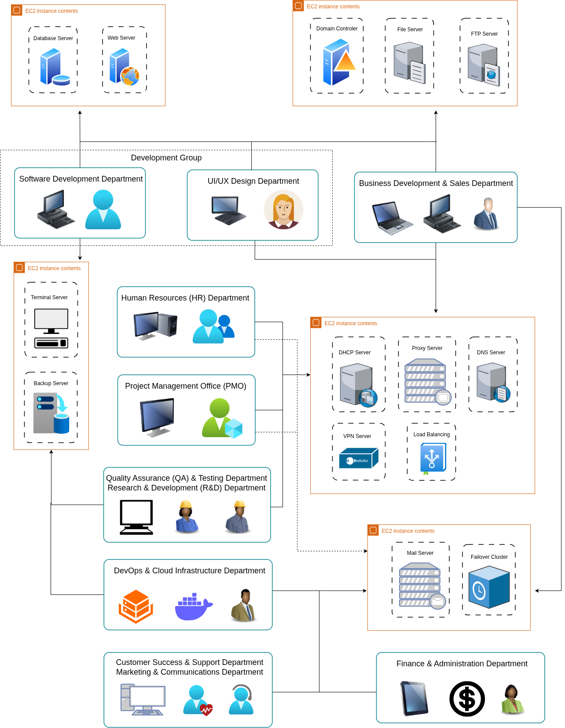

4. Conclusion
In conclusion, DevSpeed Technologies Co., Ltd. has established a well-structured and efficient IT infrastructure powered by Windows Server 2022 to support its diverse operations and development needs. The company’s integrated server environment ensures reliability, security, and scalability across all departments, enabling seamless collaboration and service delivery. Each department plays a vital role in driving innovation, maintaining quality, and achieving organizational goals. With a focus on technology, teamwork, and continuous improvement, DevSpeed Technologies is well-positioned to deliver cutting-edge digital solutions and sustain long-term growth in an evolving digital landscape.

